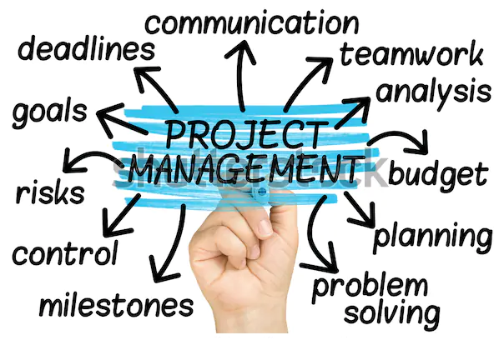

Facilitate Conversation

Decision Making

Build Relationships

Holistic View & Alignment

Leadership

Negotiation

Scheduling

Cost Control

Risk Management

Contract Management

Critical Thinking

Project Recovery

Coaching

Task Management

Quality Management

A Sense of Humour